
Name of the Experiement : Wallet on Testnet – Set Up and Transact
Coding Phase : Pseudo Code/Flow Chart/Algorithm
Algorithm:
- 1.Start
- 2.Install and setup your metamask wallet in the browser
- 3.Switch the network to sepolia testnet
- 4.Then search for ethereum sepolia faucet in browser
- 5.Paste your wallet address and click on receive sepolia ETH
- 6.Testnet sepolia ETH will directly be received in your wallet
- 7.Now click on send and paste someone else’s wallet address
- 8.Confirm transaction on etherscan
- 9.End
Apparatus/Software Used:
- 1.Metamask wallet
- 2.Ethereum Sepolia Faucet
- 3.Brave browser

Applied and Action Learning
Implementation Phase: Final Output (no error)

First setup your metamask wallet in the browser and then switch the network to sepolia testnet
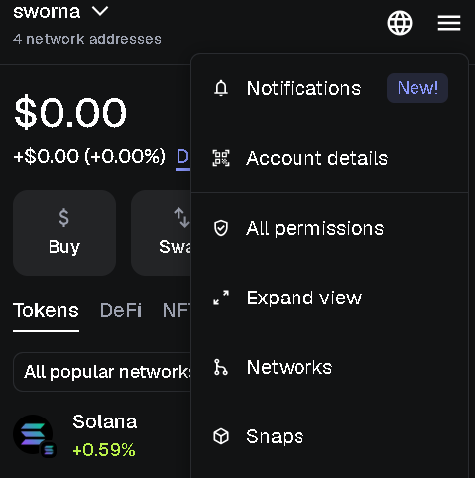
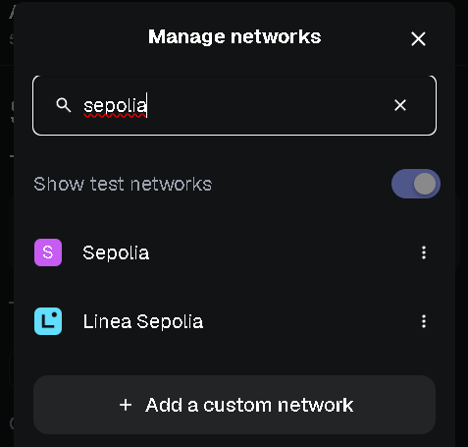

Now search for google cloud sepolia faucet then paste your wallet address to get
sepolia ETH.
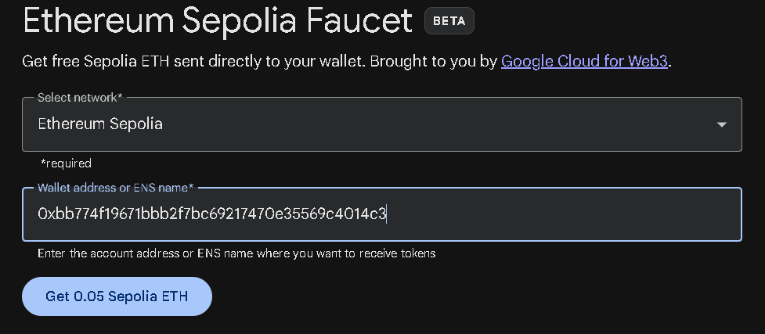
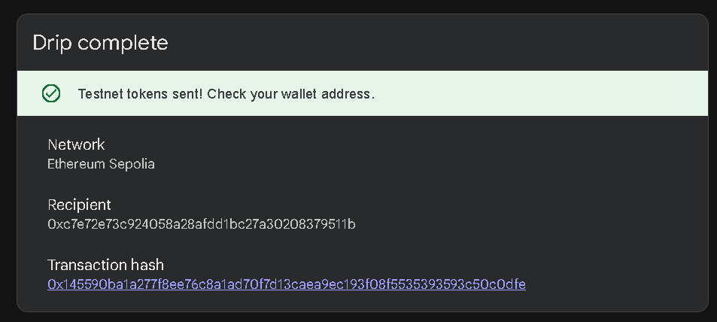
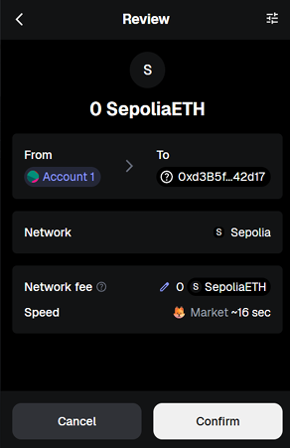
Now in your metamask wallet go to send and paste someone else’s wallet address and confirm the transaction
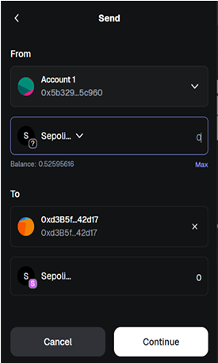
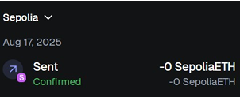
Implementation Phase: Final Output (no error)
Observations :

- A wallet on the testnet allows safe practice of sending, receiving, and managing crypto transactions without using real funds.
- Testnet transactions demonstrate how blockchain confirmations, balances, and addresses work in a risk-free environment

